Wesley Kepke
CS 460 – Compiler Construction – Dr. Fred Harris
PA4 – Calculator Yacc (Bison) File
- This screen-shot shows various input to my calculator program. Much of the input has whitespace; this demonstrates that my program is not affected by whitespace and can compute values as expected. Moreover, the last line shows an invalid input.
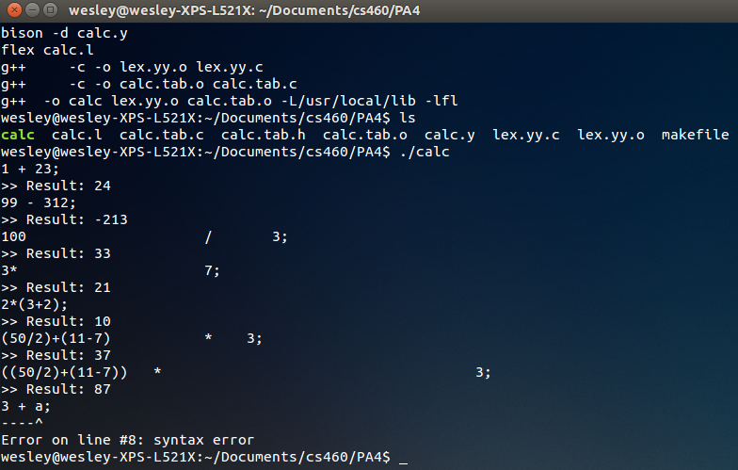
- This screen-shot shows some syntax errors and the message that appears when each is encountered. I've included a carrot symbol under the token that caused the error.
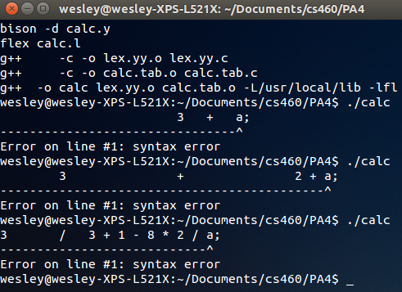
- This final screen-shot shows what happens when a value too large for an int datatype is entered into the program, when the user attempts to divide by 0, and when the result of an addition yields a value that is too large for an int datatype (respectively). Each error corresponds to a different error message.
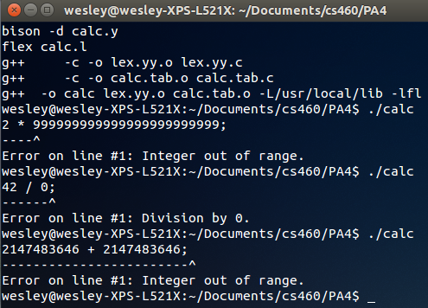

- The code for both calc.l and calc.y is included in the remaining pages of this document.

